INTERNSPARK DATA ANALYTICS INTERNSHIP REPORT

Submitted By: Saumya Dayal
Domain: Data Analytics
GitHub Repository:
saumyadayal/InternSpark-Data-Analytics-Internship: Data Analytics Internship Projects featuring Customer Behavior Analysis, Sales Performance Analysis, and Website Traffic Analysis using Python, Pandas, and Data Visualization techniques.

TABLE OF CONTENTS
- Customer Behavior Analysis
- Sales Performance Analysis
- Website Traffic Analysis
- Internship Learning Outcomes
- GitHub Repository

PROJECT 1
CUSTOMER BEHAVIOR ANALYSIS
Executive Summary
The objective of this project was to analyze customer purchasing behavior using an e-commerce dataset. The analysis focused on understanding customer demographics, purchasing preferences, payment methods, customer retention patterns, and customer segmentation. Exploratory Data Analysis (EDA) and RFM (Recency, Frequency, Monetary) Analysis were used to identify customer groups and generate business insights.
Project Objectives
• Understand customer purchasing behavior.
• Analyze customer demographics and preferences.
• Study payment methods and transaction patterns.
• Identify customer retention and churn trends.
• Perform customer segmentation using RFM Analysis.
Dataset Overview
The dataset contains information regarding customers, their purchases, product categories, payment preferences, and transaction behavior.
[DATASET PREVIEW / FIRST FEW ROWS]
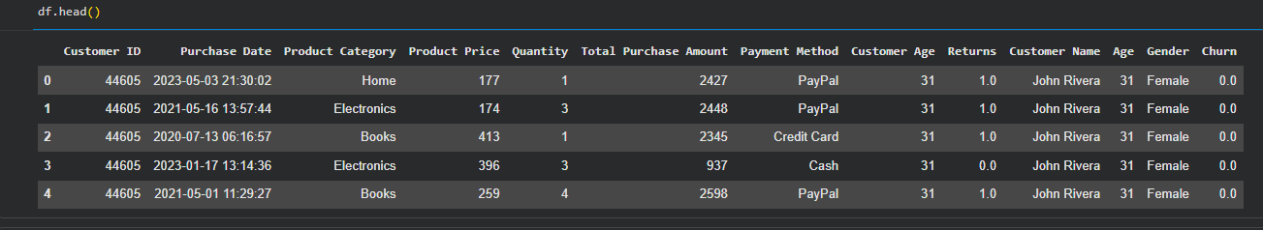

Methodology
The following steps were performed:
• Data Cleaning
• Handling missing values
• Exploratory Data Analysis
• Customer behavior visualization
• Customer segmentation
• Business insight generation
Key Visualizations
[CUSTOMER DEMOGRAPHICS OR PRODUCT CATEGORY ANALYSIS]
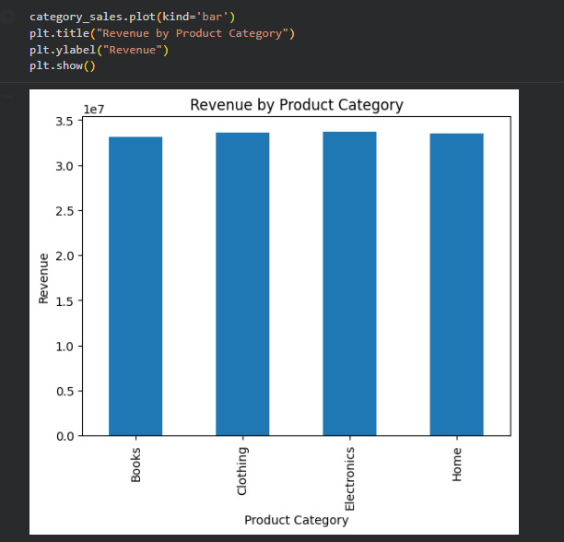

[CHURN ANALYSIS OR RFM SEGMENTATION CHART]
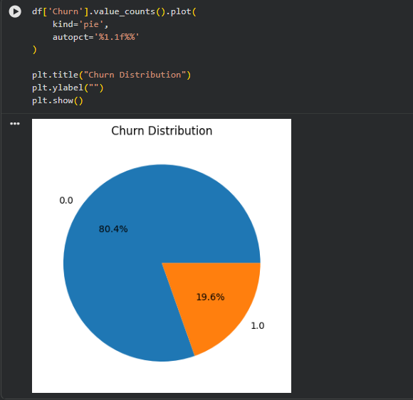

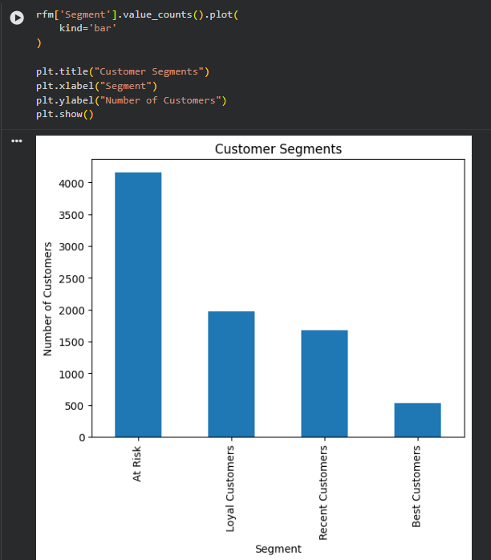
Results and Findings
• Customer behavior differs across product categories.
• Certain customer groups contribute significantly higher revenue.
• RFM analysis helps identify loyal customers and customers at risk of churn.
• Customer segmentation can improve marketing efficiency and customer retention strategies.
Business Recommendations
• Focus retention campaigns on high-value customers.
• Develop targeted offers for customers with declining activity.
• Improve engagement with at-risk customer segments.
• Use customer segmentation for personalized marketing.

PROJECT 2
SALES PERFORMANCE ANALYSIS
Executive Summary
The objective of this project was to evaluate sales performance using a retail sales dataset. The analysis focused on identifying sales trends, profitability patterns, category performance, and regional business performance. The project provides data-driven recommendations for improving overall business performance.
Project Objectives
• Analyze sales trends.
• Evaluate profitability.
• Identify high-performing categories.
• Compare regional performance.
• Generate business recommendations.
Dataset Overview
The dataset contains sales transactions, profit values, customer segments, product categories, and regional information.
[DATASET PREVIEW]
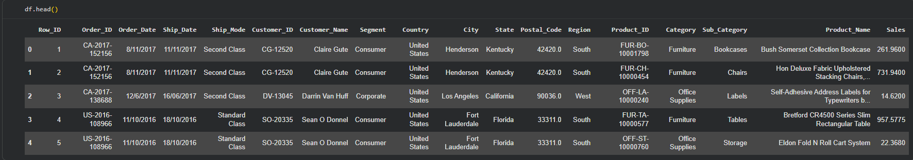
Methodology
The following analytical techniques were used:
• Data Cleaning
• Exploratory Data Analysis
• Sales Trend Analysis
• Profitability Analysis
• Regional Analysis
• Category Analysis
Key Visualizations

[SALES TREND ANALYSIS]
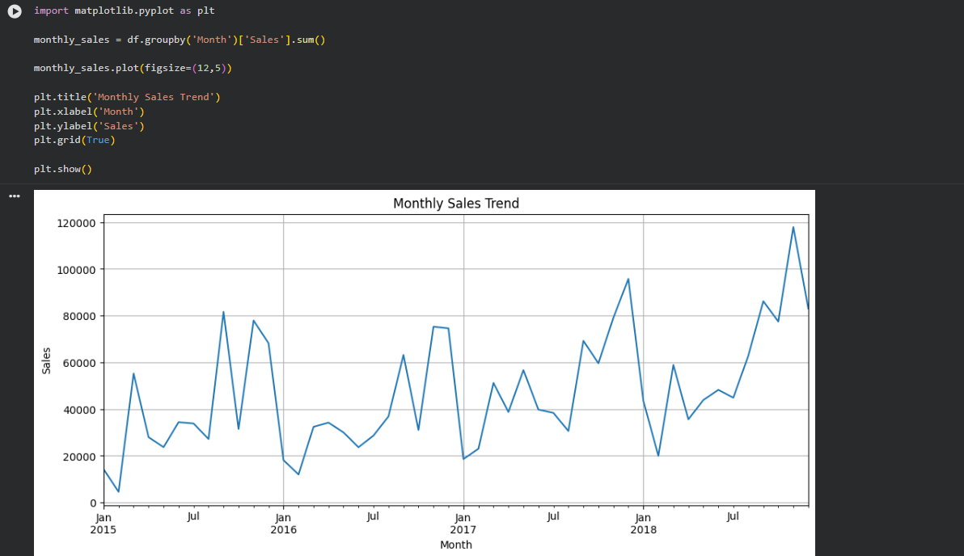
[PROFIT ANALYSIS / CATEGORY PERFORMANCE / REGIONAL PERFORMANCE]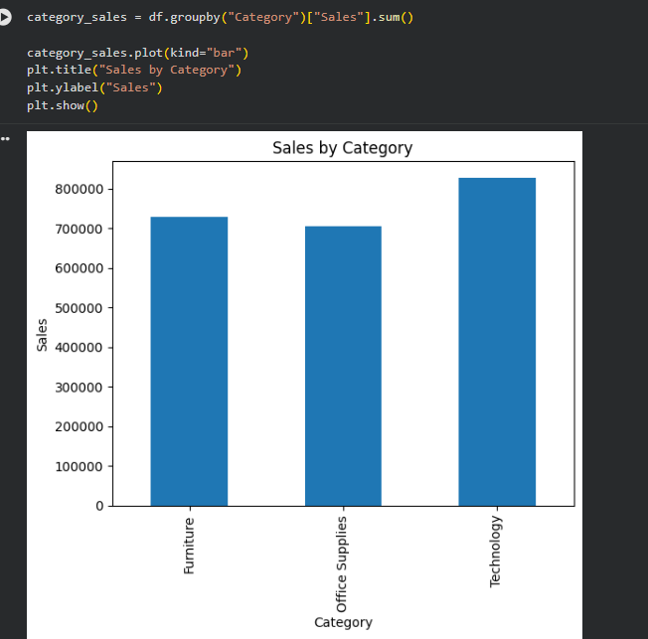

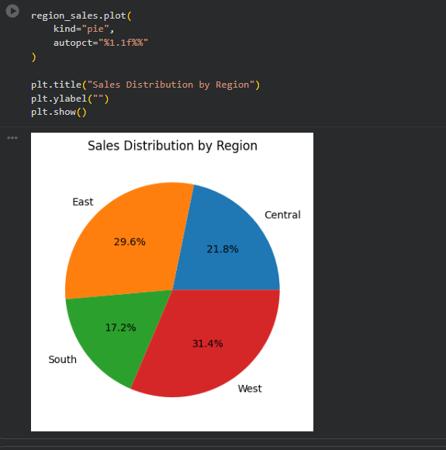

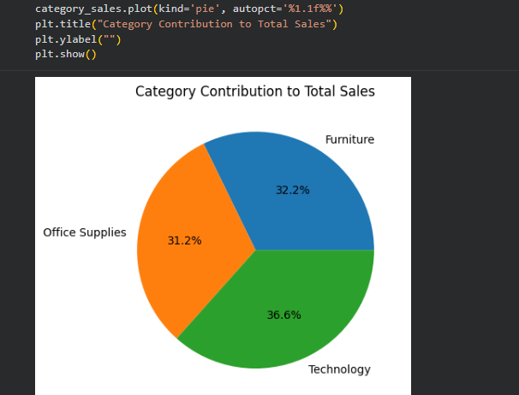

Results and Findings
• Sales performance varies across categories and regions.
• Some categories generate strong revenue but lower profitability.
• Certain regions outperform others in overall sales performance.
• Profit trends highlight opportunities for operational improvements.
Business Recommendations
• Focus resources on high-performing categories.
• Improve profitability in low-margin segments.
• Expand successful regional strategies.
• Monitor sales trends regularly for data-driven decisions.

PROJECT 3
WEBSITE TRAFFIC ANALYSIS
Executive Summary
The objective of this project was to analyze website traffic data from a music marketing platform. The project examined visitor behavior, traffic distribution, user engagement, country-wise activity, and artist popularity trends. The analysis helps understand audience behavior and platform performance.
Project Objectives
• Analyze website traffic.
• Study visitor engagement.
• Compare traffic across countries.
• Evaluate artist popularity.
• Identify traffic and engagement trends.
Dataset Overview
The dataset contains website traffic metrics, visitor information, engagement indicators, and geographic traffic data.
[DATASET PREVIEW]
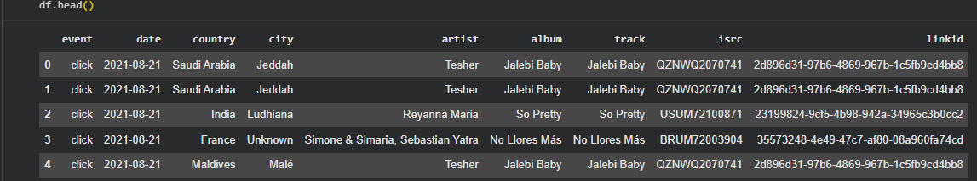
Methodology
The following steps were performed:
• Data Cleaning
• Exploratory Data Analysis
• Traffic Distribution Analysis
• Country-wise Analysis
• User Engagement Analysis
• Trend Analysis

Key Visualizations

[TRAFFIC DISTRIBUTION CHART]
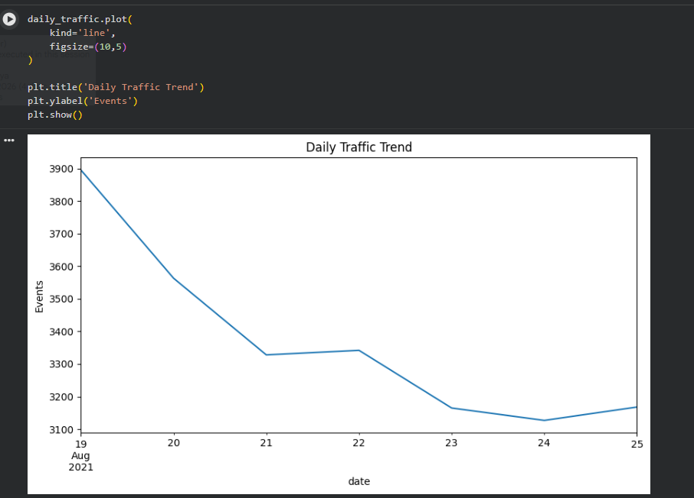

[COUNTRY-WISE TRAFFIC ANALYSIS]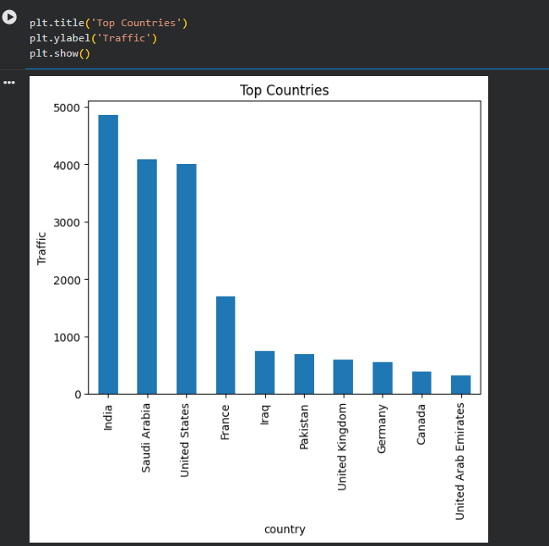
[ENGAGEMENT OR ARTIST POPULARITY ANALYSIS]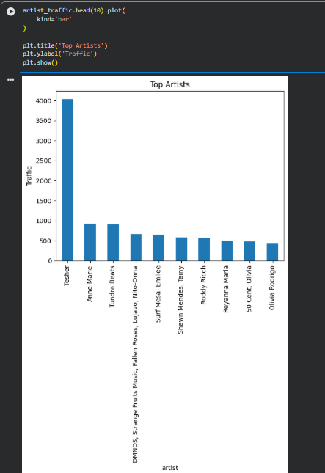

Results and Findings
• Traffic is concentrated in specific geographic regions.
• User engagement varies across different content categories.
• Artist popularity impacts website interaction levels.
• Traffic analysis provides valuable marketing insights.
Business Recommendations
• Focus marketing efforts on high-engagement regions.
• Improve content targeting based on user preferences.
• Monitor engagement metrics regularly.
• Use trend analysis to support future campaigns.

INTERNSHIP LEARNING OUTCOMES
During this internship, I developed practical skills in:
• Data Cleaning and Preprocessing
• Exploratory Data Analysis (EDA)
• Data Visualization
• Customer Analytics
• Sales Analytics
• Website Traffic Analytics
• Business Reporting
• Business Insight Generation
• Data Storytelling
Tools and Technologies Used
• Python
• Pandas
• NumPy
• Matplotlib
• Seaborn
• Google Colab

GITHUB REPOSITORY
GitHub Link:
saumyadayal/InternSpark-Data-Analytics-Internship: Data Analytics Internship Projects featuring Customer Behavior Analysis, Sales Performance Analysis, and Website Traffic Analysis using Python, Pandas, and Data Visualization techniques.

GITHUB REPOSITORY HOMEPAGE
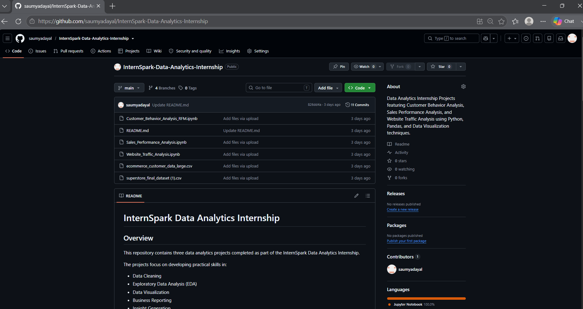

Repository Includes
• Project Notebooks
• Datasets
• Visualizations
• Documentation
• README File
CONCLUSION
This internship provided valuable hands-on experience in data analytics and business intelligence. Through multiple projects, I learned how to clean datasets, analyze data, create visualizations, generate business insights, and document findings professionally. The experience strengthened my practical understanding of data analytics tools and real-world business applications.
Thank You.

